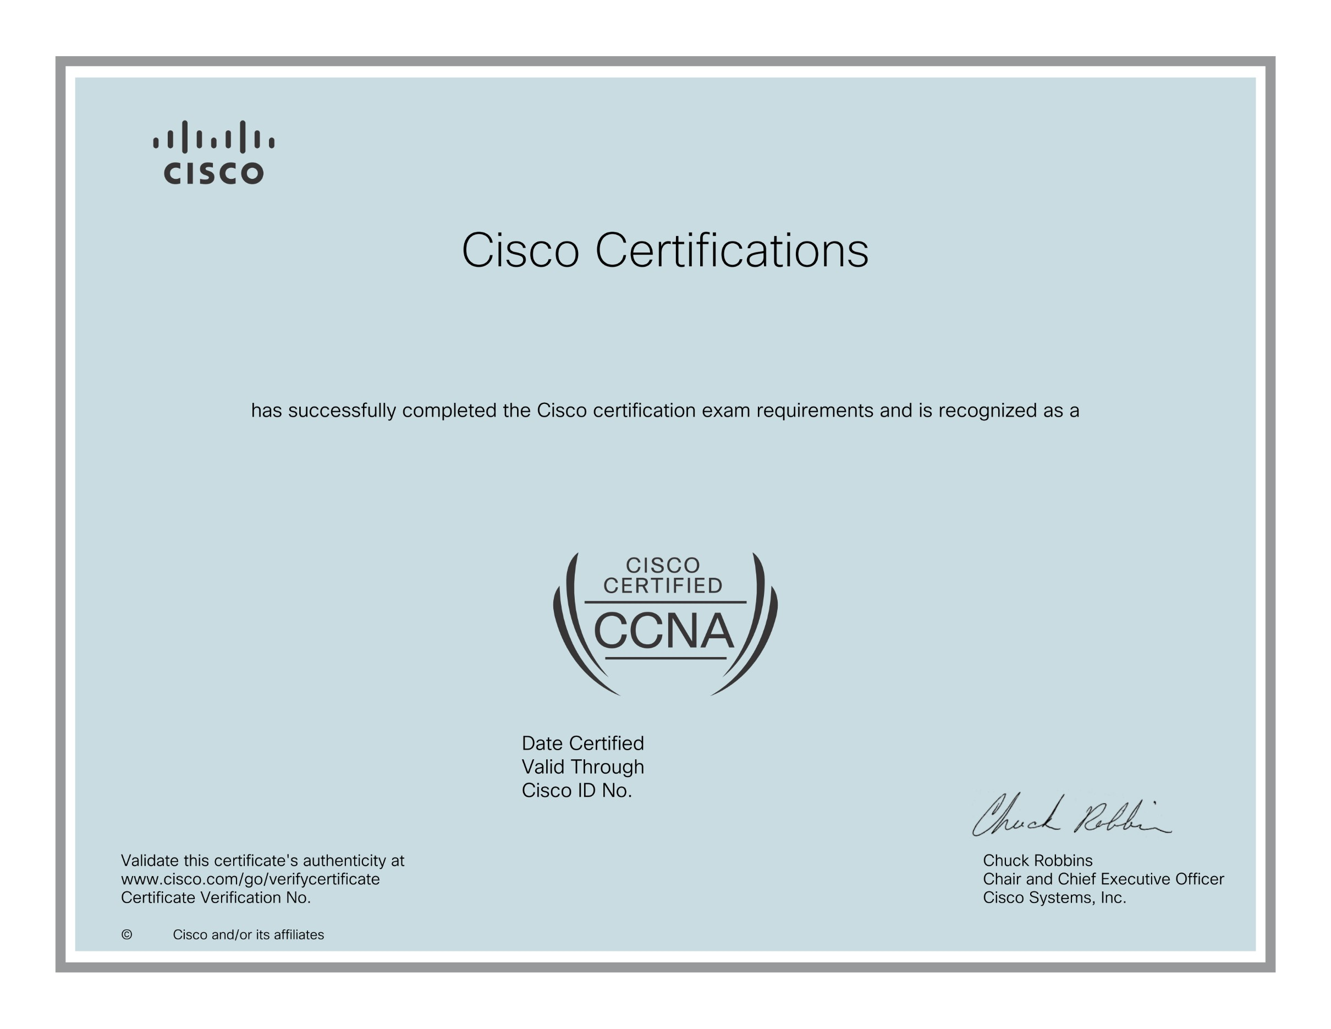

April 29, 2025

Jean Claude ISHIMWE

Cisco Certified Network Associate

April 29, 2028

CSCO14565777

0

b63b74b91fb45fcb9ffa3c62f59252e

2025